**MCA - 1 ASWD Git Practical 2022-2023**

**1.Know your path**

imrd@imrdcomp36 MINGW64 ~

$ pwd

/c/Users/imrd

imrd@imrdcomp36 MINGW64 ~

$ cd Desktop

imrd@imrdcomp36 MINGW64 ~/Desktop

$ pwd

/c/Users/imrd/Desktop

**2.create your own repository on local computer**

imrd@imrdcomp36 MINGW64 ~/Desktop

$ mkdir mca

imrd@imrdcomp36 MINGW64 ~/Desktop

$ cd mca

imrd@imrdcomp36 MINGW64 ~/Desktop/mca

$ pwd

/c/Users/imrd/Desktop/mca

**3.initialize git**

imrd@imrdcomp36 MINGW64 ~/Desktop/mca

$ git init

Initialized empty Git repository in C:/Users/imrd/Desktop/mca/.git/

**4.config commands**

**Add your user name and email**

imrd@imrdcomp36 MINGW64 ~/Desktop/mca (master)

$ git config --global user.name "mca-1"

**5.if already exist replace**

imrd@imrdcomp36 MINGW64 ~/Desktop/mca (master)

$ git config --global --replace-all user.email "umargd123@gmail.com"

**6.verify your email address according to github email**

imrd@imrdcomp36 MINGW64 ~/Desktop/mca (master)

$ git config --global user.email

umargd123@gmail.com

**7.create your file**

imrd@imrdcomp36 MINGW64 ~/Desktop/mca (master)

$ touch f1.txt

**8.edit created file write something**

imrd@imrdcomp36 MINGW64 ~/Desktop/mca (master)

$ notepad f1.txt

**9.add file to staging area**

imrd@imrdcomp36 MINGW64 ~/Desktop/mca (master)

$ git add f1.txt

**10.commit changes**

imrd@imrdcomp36 MINGW64 ~/Desktop/mca (master)

$ git commit -m"fist"

[master (root-commit) 444a9ea] fist

1 file changed, 1 insertion(+)

create mode 100644 f1.txt

**11.create new branch**

imrd@imrdcomp36 MINGW64 ~/Desktop/mca (master)

$ git branch mca

imrd@imrdcomp36 MINGW64 ~/Desktop/mca (master)

$ git branch

* master

mca

**12.switch to your branch**

imrd@imrdcomp36 MINGW64 ~/Desktop/mca (master)

$ git checkout mca

Switched to branch 'mca'

**13.check git status**

imrd@imrdcomp36 MINGW64 ~/Desktop/mca (mca)

$ git status

On branch mca

nothing to commit, working tree clean

**14.check git log**

imrd@imrdcomp36 MINGW64 ~/Desktop/mca (mca)

$ git log -v

commit 444a9eaff3d7acf01782fef5dcf9f50bc6721b98 (HEAD -> mca, master)

Author: mca-1 <umargd123@gmail.com>

Date: Wed Jun 29 09:37:31 2022 +0530

fist

**15.generate SSH key**

// find commands on github setting

// copy paste the commands

imrd@imrdcomp36 MINGW64 ~/Desktop/mca (mca)

$ ssh-keygen -t ed25519 -C "umargd123@gmail.com"

Generating public/private ed25519 key pair.

Enter file in which to save the key (/c/Users/imrd/.ssh/id_ed25519):

Created directory '/c/Users/imrd/.ssh'.

Enter passphrase (empty for no passphrase):

Enter same passphrase again:

Your identification has been saved in /c/Users/imrd/.ssh/id_ed25519

Your public key has been saved in /c/Users/imrd/.ssh/id_ed25519.pub

The key fingerprint is:

SHA256:RIrGSkh0RjDvHdTXtGKvUXMW0r/LBnud8EdoWop3kH0 umargd123@gmail.com

The key's randomart image is:

+--[ED25519 256]--+

|.=o+ .. . oo.. |

|..=... + . .o.. |

|. ..+.. oo + o. |

| ..o. ... + + . |

| .. . S. . o ..|

| o oo=.E|

| . . **o+|

| . +..Bo|

| . .o .|

+----[SHA256]-----+

imrd@imrdcomp36 MINGW64 ~/Desktop/mca (mca)

$ eval "$(ssh-agent -s)"

Agent pid 1210

imrd@imrdcomp36 MINGW64 ~/Desktop/mca (mca)

$ ssh-add ~/.ssh/id_ed25519

Identity added: /c/Users/imrd/.ssh/id_ed25519 (umargd123@gmail.com)

**16.copy SSH key and paste to generate new key**

imrd@imrdcomp36 MINGW64 ~/Desktop/mca (mca)

$ clip < ~/.ssh/id_ed25519.pub

// after this paste the copied id to generate new key

**17.create new repository and copy paste the commands**

imrd@imrdcomp36 MINGW64 ~/Desktop/mca (mca)

$ git remote add origin https://github.com/Umarkhan7312/mca-1.git

**18.push changes to git account**

// verify branch name before push operation

imrd@imrdcomp36 MINGW64 ~/Desktop/mca (mca)

$ git push -u origin mca

Enumerating objects: 3, done.

Counting objects: 100% (3/3), done.

Writing objects: 100% (3/3), 208 bytes | 208.00 KiB/s, done.

Total 3 (delta 0), reused 0 (delta 0), pack-reused 0

To https://github.com/Umarkhan7312/mca-1.git

* [new branch] mca -> mca

branch 'mca' set up to track 'origin/mca'.

**19.perform pull operation using branch name**

imrd@imrdcomp36 MINGW64 ~/Desktop/mca (mca)

$ git pull origin mca

From https://github.com/Umarkhan7312/mca-1

* branch mca -> FETCH_HEAD

Already up to date.

**20.perform pull operation using file path**

imrd@imrdcomp36 MINGW64 ~/Desktop/mca (mca)

$ git pull https://github.com/Umarkhan7312/mca-1.git

remote: Enumerating objects: 5, done.

remote: Counting objects: 100% (5/5), done.

remote: Total 3 (delta 0), reused 0 (delta 0), pack-reused 0

Unpacking objects: 100% (3/3), 621 bytes | 4.00 KiB/s, done.

From https://github.com/Umarkhan7312/mca-1

* branch HEAD -> FETCH_HEAD

Updating 444a9ea..7e38374

Fast-forward

f1.txt | 3 ++-

1 file changed, 2 insertions(+), 1 deletion(-)

**21.verify changes**

imrd@imrdcomp36 MINGW64 ~/Desktop/mca (mca)

$ notepad f1.txt

**22.clone git repository**

imrd@imrdcomp36 MINGW64 ~/Desktop/mca (mca)

$ git clone https://github.com/Umarkhan7312/mca-1.git

Cloning into 'mca-1'...

remote: Enumerating objects: 6, done.

remote: Counting objects: 100% (6/6), done.

remote: Compressing objects: 100% (2/2), done.

remote: Total 6 (delta 0), reused 3 (delta 0), pack-reused 0

Receiving objects: 100% (6/6), done.

23. create new branches to merge

UmarKhan pathan@Umarkhan MINGW64 ~ (master)

$ git branch

* master

UmarKhan pathan@Umarkhan MINGW64 ~ (master)

$ git branch b1

UmarKhan pathan@Umarkhan MINGW64 ~ (master)

$ git branch b2

UmarKhan pathan@Umarkhan MINGW64 ~ (master)

$ git branch

b1

b2

* master

–

// add files in new branches and checkout to master branch

UmarKhan pathan@Umarkhan MINGW64 ~ (master)

$ git merge b1 b2

Updating f0a986b..2948d20

Fast-forward

b1.txt | 0

1 file changed, 0 insertions(+), 0 deletions(-)

create mode 100644 b1.txt

24. git dif

It tracks the diff betn thr changes made on files

UmarKhan pathan@Umarkhan MINGW64 ~ (master)

$ git diff

**diff --git a/umar35/f1.txt b/umar35/f1.txt**

**index 8d9fcd6..ab310ee 100644**

**--- a/umar35/f1.txt**

**+++ b/umar35/f1.txt**

@@ -25,8 +25,8 @@ ssh-ed25519 AAAAC3NzaC1lZDI1NTE5AAAAIEkPdLl5AxO5uMxMj+zQND3ySppFkQI8FNbkIHq+74JF

git remote add origin https://github.com/Umarkhan7312/umar35.git

-

-

+git push -u origin master

git log -v

// check for existing remote

UmarKhan pathan@Umarkhan MINGW64 ~ (master)

$ git remote -v

origin https://github.com/Umarkhan7312/umar35.git (fetch)

origin https://github.com/Umarkhan7312/umar35.git (push)

// generate token with no expiration date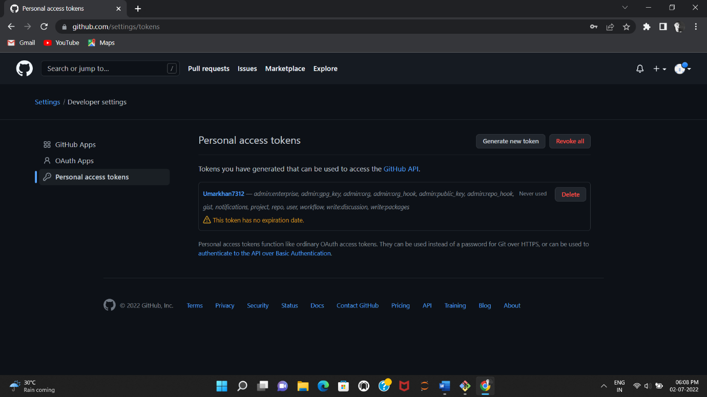

// remove existing remote address

UmarKhan pathan@Umarkhan MINGW64 ~ (master)

$ git remote add origin main

error: remote origin already exists.

UmarKhan pathan@Umarkhan MINGW64 ~ (master)

$ git remote rm origin main

usage: git remote remove <name>